Professional Programming Practice – Assignment 4

Prekshya Sharma - 11625754

BUG 7– Player cannot change his name and balance
Description: The player’s is hardcoded Fred with balance of 100, but what if someone else who’s different name wants to play the game with a different amount of balance?

- Replication
At the Main class the player instance is initialise with name is Fred and balance is 100:
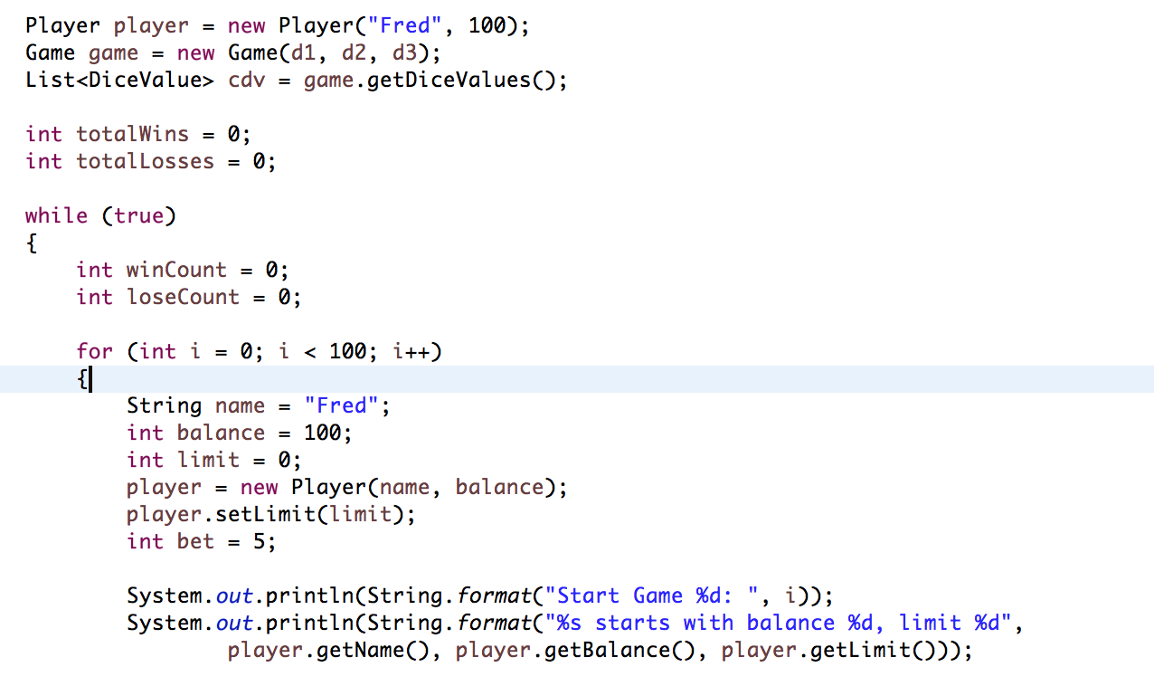
The name and balance is hard coded.

2. Simplification & Tracing
Before hard coding the variables, the game should offer a choice for player to enter his name and his available balance:

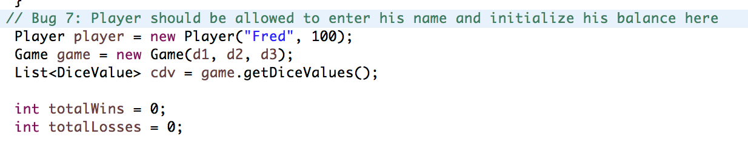
4. Resolution
Code is added to ask for player’s name and his balance. Exceptions are checked and default balance can be used when an exception caught:
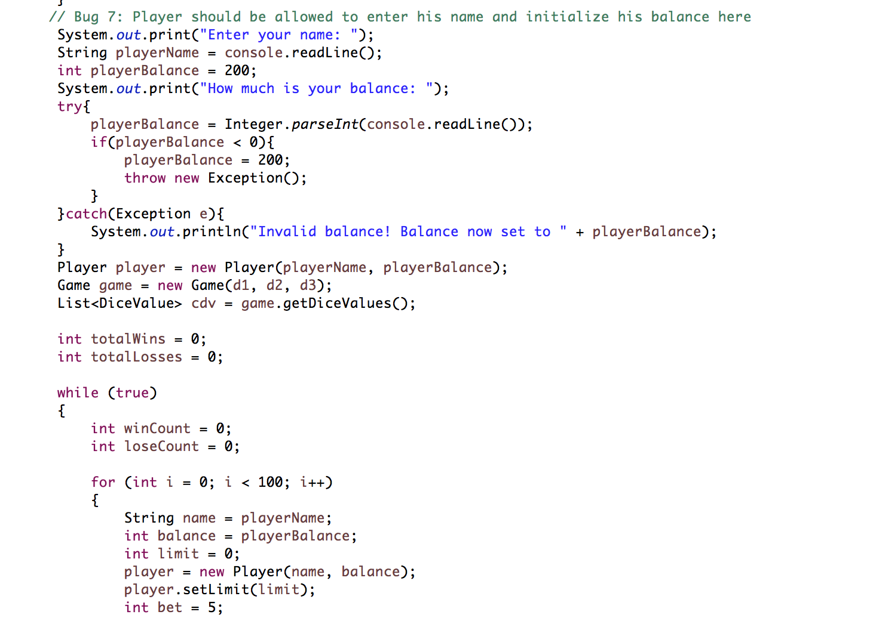

Now if John plays the game:

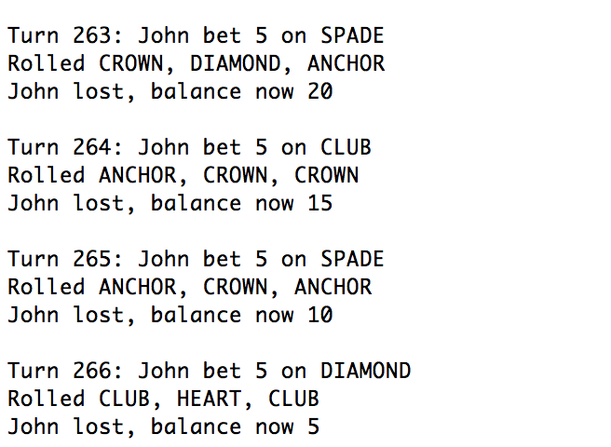

He also starts with his entered balance (150):

